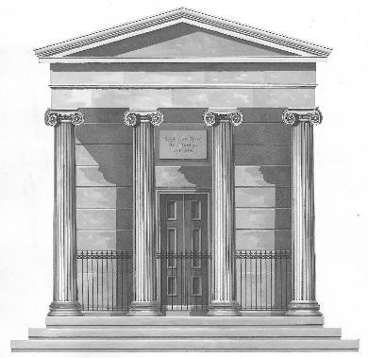
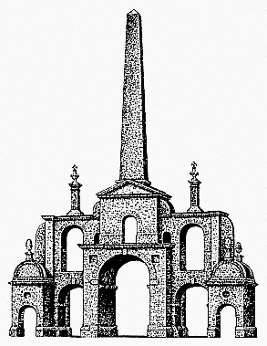
Birr and Midlands Chapter Irish Georgian Society

Conserving Ireland’s Architectural Heritage

Dear Members,
The Birr/Midlands Chapter of the Irish Georgian Society holds its Christmas Party this year at
Birr Castle on Friday 6 December, 2019
CASTLE GATES OPEN : 7.30pm for 8 pm : Entrance : 25€
If you wish to join us, please fill in the form below and return with payment (cheque, postal order or cash) to the undersigned, by Thursday 28 November 2019, OR email, telephone or text : Eilishfog@gmail.com Telephone 087 609 0010 to reserve.
We hope to see you there.
Best regards,
Elizabeth Fogarty, Hon. Secretary
Cut here…………………………………………………………Cut here…………………………………………………………..Cut here

Name:
Address:_____________________________________________________________________________________
Phone/Mobile : ______________________ Email:_______________________________
I wish to attend the Birr/Midlands IGS Chapter Christmas Party at Birr Castle, Friday 6 December, 2019.
Payment : I enclose a cheque/postal order/cash for _____________ in payment for _________places
Please return by Thursday 28 November 2019 to Elizabeth Fogarty, 6 Millview, Sandymount, Birr R42 FX 99, Co Offaly OR email, telephone or text : eilishfog@gmail.com Telephone 087 609 0010

PATRON ; Earl of Rosse
Executive Committee: John Joyce (Chairman), Elizabeth Fogarty (Hon Sec.), Gerard Browne (Hon Treasurer) : www.igs.ie
,,,,

