**St. Angela’s College, St. Patrick’s Hill, Cork**

**O’Donnell + Tuomey Architectural Experience**

**Saturday, 29th February 2020 @ 10.45am**

10.45 am               Meet at St. Angela’s College, St. Patrick’s Hill, Cork for registration.

11.00 am               Tour of St. Angela’s College, courtesy of Mr. Curran School Principal.

1.00 pm                 Lunch at Isaac’s Restaurant, McCurtain Street, Cork.

**St. Angela’s College** was founded in 1887 by the Ursuline Sisters at 29, St. Patrick's Hill.  Since its establishment the expansion of the school resulted in the purchase of adjacent buildings, such as Richmond House which was formerly owned by Jeremiah Murphy, one of the founders of Murphy’s Brewery.

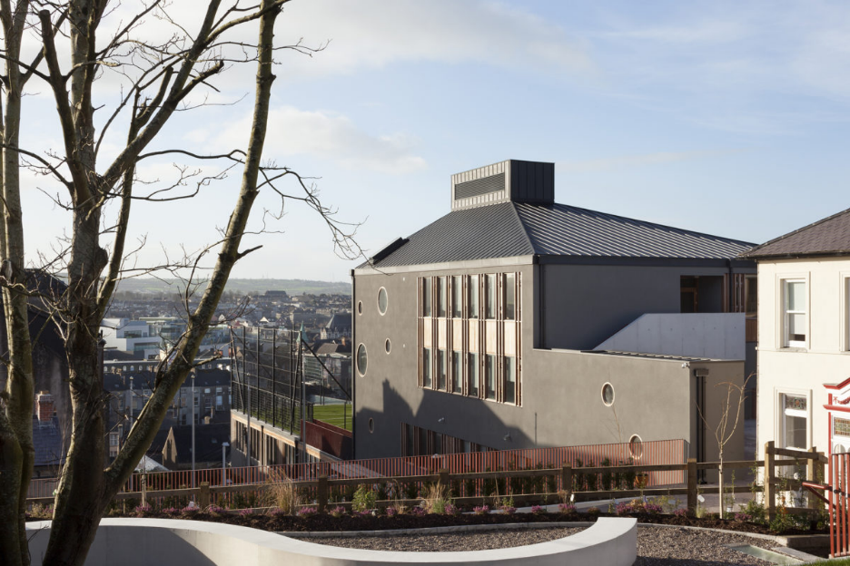In 2015 this cluster of buildings was redesigned and redeveloped by architects **O'Donnell + Tuomey**, who in 2016 received a RIBA Award of International Excellence for their outstanding project. **O’Donnell + Tuomey** was founded in Dublin in 1988 by Sheila O’Donnell and John Tuomey. The practice began with two public commissions arising from their cultural and social engagement: the Irish Film Institute and Ranelagh Multi-denominational School.  In 2005 they won they were a RIBA Stirling Award finalist for the UCC Glucksman Gallery for which they received a RIBA Best Building Award.

* **Tickets** cost €40 (members), €45 (non-members) and must be purchased in advance by completing the booking form below.
* **Terms & Conditions:** Participation at the discretion of the committee. No bookings accepted without payment.  Attendees must provide own transport.  Programme subject to change without notice.

Please mail the booking form to Geraldine O’Riordan, 4 The Beeches, Woodville, Dunkettle, Glanmire, Co. Cork (Tel: 087-2755764 or email: [geraldineoriordan28@gmail.com](mailto:geraldineoriordan28@gmail.com))  Please make your cheque payable to the Irish Georgian Society, *Cork Chapter*.

BOOKING FORM FOR ‘**St. Angela’s College**, St. Patrick’s Hill’ - Saturday, **29th February 2020**.

Name: ……………………………………………………………………….…………………………………………………………

Address: …………………………………………………………………………………………………………………………………

……………………………………………………………………………………………………………………………………………….

Tel: …………………………….…… E-mail: ……………………………………………………………………………………

No. of Tickets: ………………….….. Payment encl.: € ……………… Membership No.: …...……..

Kevin Hurley  
Cork Chapter  
Irish Georgian Society  
Mobile: 087-9266826

E-mail: [cork@igs.ie](mailto:cork@igs.ie)

Blog: [igscork.blogspot.com](http://igscork.blogspot.com/)

Web: [www.igs.ie](http://www.igs.ie/)