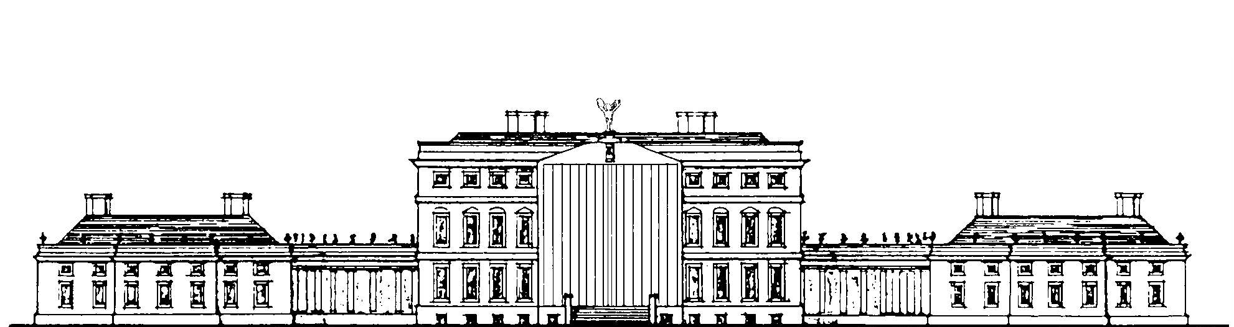

TOUR OF DERBYSHIRE with the 20-GHOST CLUB
MONDAY 9th to FRIDAY 13th MAY 2022

As Irish Georgians will be aware, our first Country House tour with the 20-Ghost was to Oxfordshire in 1978, and these tours are now a firm fixture in the annual calendar of both societies. This year’s tour will be in Derbyshire, last visited together 39 years ago (1983!), and all agreed that it is certainly time for a return visit. This event is most welcome, it being three years since the last one, North West Ireland in 2019.

Derbyshire is known for being the county with some of the greatest houses in the land. As always, a number of the houses we will be visiting are still in private hands – many of them for centuries. The itinerary is not finalised at the time of writing this, so things are still somewhat fluid. So far we have concentrated on lining up the less well known houses and the tour is expected to include Melbourne Hall, Staunton Harold Hall, Tissington Hall, Renishaw Hall, Locko Park, Radbourne Hall and Wootton Hall. Others are in the pipeline, and members should remember that the itinerary is subject to change as details are confirmed. We are not including a visit to Chatsworth during the tour, as it is expected that most members will have visited the house and gardens in the past. However, you might like to consider a visit either side of the established tour. In view of the large number of houses to be visited, at a slightly slower place than previous tours – and the logistics involved – it has been decided to start the tour immediately after breakfast on Tuesday 10th May, and to finish as usual in the late afternoon on Friday 13th May. More precise details will be sent to all those booked on the tour when the arrangements and itinerary have been confirmed. As always, our transport with be provided by the magnificent pre-1939 Rolls Royces of the 20 Ghost Club.

The tour will be based at the Breadsall Priory Hotel, Moor Road, Morley, Derby DE7 6DL. The hotel is approx 5 miles north of Derby. To quote from the hotel’s website: “Nowhere does the allure of history meet modern comforts more elegantly”. We shall see!

The cost will be £890.00 per person sharing and will include dinner, bed & breakfast for the nights of Monday 9th, Tuesday 10th, Wednesday 11th and Thursday 12th, lunch on Tuesday, Wednesday, Thursday & Friday, drinks at most meals, and house entrance fees. There are a few rooms available for single occupancy , for ££1,030.00. We have to take into account a number of factors when allocating places so applications cannot be on a ‘first- come, first served’ basis; just ensure that your application has been received by FRIDAY 4TH MARCH. If you would like accommodation at the hotel for additional nights either before or after the tour, you will have to make your own arrangements direct with the hotel, but do not do this purchase train or other travel tickets until your place on the tour has been confirmed.

If you would like to come on the tour, please complete the attached application form and return it to Mrs Marylyn Bacon, Ramsden, Stone-cum-Ebony, Nr. Tenterden, Kent TN30 7JB, with a cheque for the appropriate payment and a SAE. The number of places for members of the IGS London is limited [about half the places are for 20-Ghost Club members] so please return the form no later than Friday 4th March as we plan to allocate places soon after then. In the event of over-subscription, a ballot may be required. For insurance and other reasons, only those whom have paid their 2022 subscriptions can be accepted on this tour.

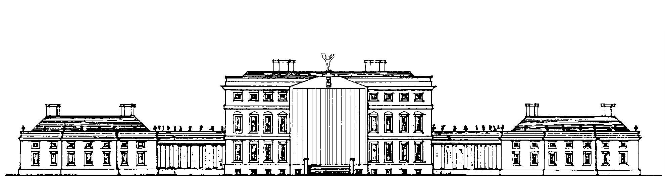

TOUR OF DERBYSHIRE with the 20-GHOST CLUB
MONDAY 9th to FRIDAY 13th MAY 2022

Please reserve places at £1,780.00 for 2 sharing in a double / twin room [please circle as required]
Please reserve place/s at £1,030.00 per person in a single room.

NAME[S] OF MEMBER[S]

…………………………………………………………………………………………………….

…………………………………………………………………………………………………………………………………

Address………………………………………………………………………………………………………………………

…………………………………………………………………………………………………………………………………..

…………………………………………… Postcode …………………............ IGS membership no. ………..

Tel (both home & mobile) …………………………………………………………………………………………..

Email address [legibly, and in capitals please!] ……………………………………………………………..

Dietary requirements, if any ………………………………………………………………………………………

I/we enclose a cheque made out to “Irish Georgian Society London” for £1,780 for 2 sharing [double or twin [please circle above as required], or £1,030 for single room occupancy.

I confirm that I am a current member of the Irish Georgian Society.

[signed] ………………………………………………………………………………………………………………………………

Please return this completed form, together with your cheque for payment and a SAE, to Mrs Marylyn Bacon, Ramsden, Stone-cum-Ebony, Nr Tenterden, Kent TN30 7JB on or before Friday 4th March [email: streakybacon@ramsdenfarm.co.uk].

