The Cork Chapter presents Loughton House House and Shanbally House & Garden

* 9.00am Coach leaves Radisson Blue Hotel Little Island Co. Cork
* 10.15am Registration at Horse and Jockey
* 10.30am Tea/coffee - Horse and Jockey
* 11.00am Depart for Loughton House.

Loughton House was Built in 1777 on lands owned by the Pepper family and can be traced back to the Cromwellian period of Irish history. An additional antiquity – the ruins of the original Norman tower/castle can still be seen behind the main house. The Pepper family lived at Loughton House until one Thomas Pepper died as a result of a hunting accident. Thomas Pepper was married to Miss Bloomfield and requested in his will that his brother-in-law, the 1st Lord Bloomfield, acquire Loughton House. Mr Trench succeeded to the property from his brother-in-law, the 2nd Lord Bloomfield, in 1870. The Trenches remained in residence until 1973 when the property was passed to the Atkinson family. The current owners purchased the property in 2016.

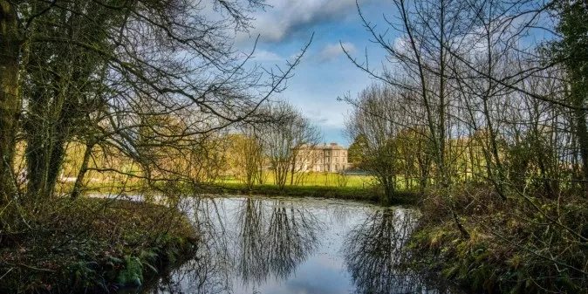

Set in one hundred acres of park and woodland, there are several acres of stunning formal gardens. The exquisite Loughton House Estate & Gardens is one of the finest examples of Georgian architecture in Ireland. (<https://loughtonhouse.com/>)

* 12.00pm Tour Loughton House and Gardens Moneygall Co. Offaly
* 2.00pm Lunch
* 3.30pm Tour Shanbally House and Gardens  Nenagh Co. Tipperary

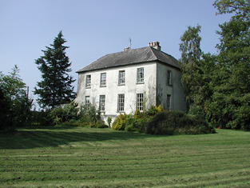This house was built circa 1770 and has a distinctive roofline due to its clusters of chimneypots and steeply-hipped roof. It retains its timber sash windows, slate roof, and rendered walls. The limestone quoins, coloured glass and render door surround add interest to the entrance porch.

When Noel and Bridget Duggan purchased Shanbally Estate Nenagh Co. Tipperary in 2013 it  was originally part of Lisaniskey owned by the O’Meara’s.  In the 19th century Barry O’Meara became the personal physician to Napoleon.  This was discovered during the restoration of the house when some old manuscripts were discovered.

Shanbally is now a centre of excellence for herbal medicine and the restoration of the house and grounds will be complete by 2019. (<https://www.shanbally.ie/house-gardens>)

* 17.00 Conclusion of visit and coach return trip

**Tickets** cost €65 (members), €75 (non-members) including coach and lunch.   Tickets using own transport cost €50 (members), €60 (non-members) including lunch.

**Terms & Conditions:** Participation at the discretion of the committee. No bookings accepted without payment. Limited places available.  Preference will be given to members.  Programme subject to change without notice.

 Please mail the booking form to Marianne Harris, Carrigfoyle, Fermoy, Co Cork - P61 NY32 email: [carrigfoylegarden@gmail.com](mailto:carrigfoylegarden@gmail.com))  Please make your cheque payable to the Irish Georgian Society, *Cork Chapter*.

%-------------------------------------------------------------------------------------------------------------------------------------------------------

BOOKING FORM FOR Loughton House and Shanbally House – Saturday, 14th September 2019

Name: ……………………………………………………………………….………………………

Address: ……………………………………………………………………………………………..

……………………………………………………………………………………………………….

Tel: …………………………….……E-mail: ………………………………………………………

No. of Tickets: ………………….…..Payment encl.: € ………………

Membership No.: …...……..

--  
Kevin Hurley  
Cork Chapter  
Irish Georgian Society  
Mobile: 087-9266826

E-mail: [corkigs@gmail.com](mailto:corkigs@gmail.com)  
Blog: [igscork.blogspot.com](http://igscork.blogspot.com/)

Web: [www.igs.ie](http://www.igs.ie/)